**New in this version:**

NUWC Environment Builder Support

Environmental data for a given Simulation Area is now extractable directly from available OAML databases:

* Bottom Sediment Type Database (BST)
* Digital Bathymetric Database – Variable Resolution (DBDB)
* Generalized Digital Environmental Model – Variable Resolution (GDEM-V)
* Surface Marine Gridded Climatology Database (SMGC)

Where available, the database-native extraction tools are used by ESME Workbench.

Several additional configuration options are now available in the ESME Main Options dialog for configuration of OAML Database and Extraction Tool locations.

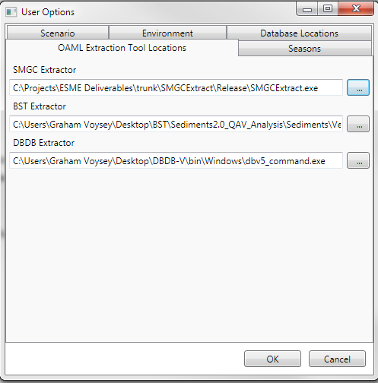

When OAML sources are to be used, the Environment Settings button on the main ribbon control allows the user to select appropriate database resolutions and time periods for extraction:

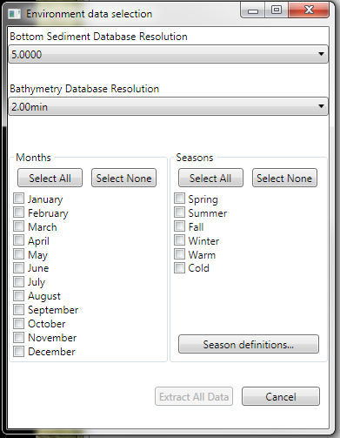

Extracted data is stored for off-line validation and verification in the Experiment Data directory in native format (BST, DBDB: CHRTR Binary; SMGC: ASCII; GDEM-V: XML)

On successful extraction, map layers corresponding to each data type extracted are loaded into the main display, and can be reordered, recolored, and otherwise manipulated like any other map layer.

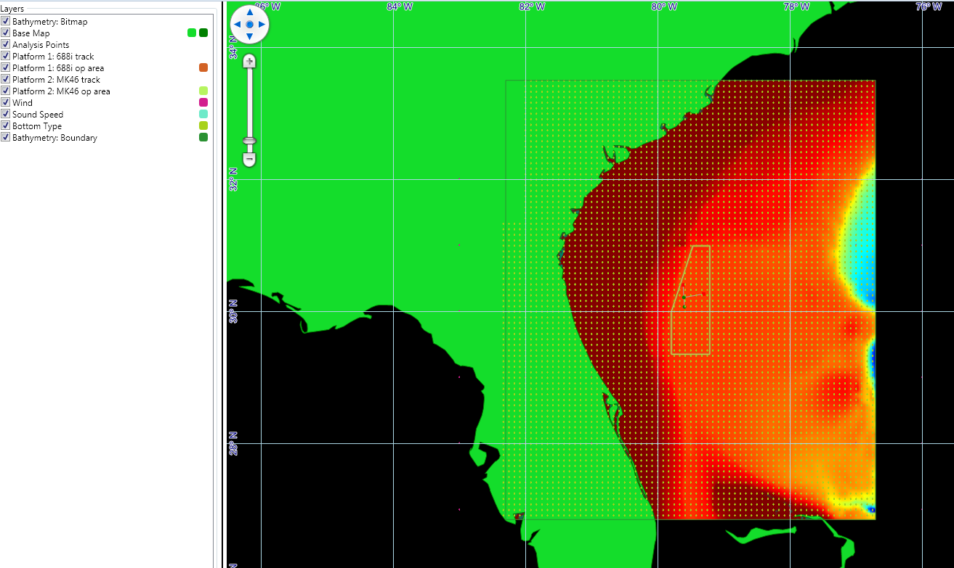

CASSomatic output:

Currently, CASSomatic-friendly versions of the environment data (of the form ‘env_timeperiod.dat’) are generated and placed in the appropriate subdirectory of the directory specified as the Scenario Data Directory in the main options dialog. This will become fully user-configurable by the next release.

**Additional Features:**

* Bathymetric bitmap map layer support.
* Recent Experiments are now listed in the main ribbon dropdown menu
* Save As: the user can now save a current experiment with a new filename with preservation of all data.

|  |
| --- |
|  |
|  |

**Bugs fixed:**

* Fixed inversion of CSV Transmission Loss output
* Fixed transmission loss color-bar display

**Known Bugs:**

* Reordering the Analysis Point layer will cause ESME to crash.